**ST Evaluation Tool**

**User Guide**

**2014-02-07**

# Instructions

**Purpose:**

ST Evaluation tool is designed for demonstrating the suitability of SmoekTrace Algorithm without Technical Knowledge of ADPRO FastTrace system and Hardware. This tool can also be used for design in order to determine the best camera angles, FOV and camera placement for SmokeTrace.

**OS:**

Windows XP sp3 and Win7 sp1 tested.

**Attention:**

* Although ST Evaluation tool uses the same SmokeTrace Algorithm as FastTrace2, there are slightly difference in there results. The results of ST Evaluation tool are for reference only.
* ST Evaluation tool would exit automatically after 24 hours.

# Quick start

1. **Extract STEvaluation.zip on your disk.**

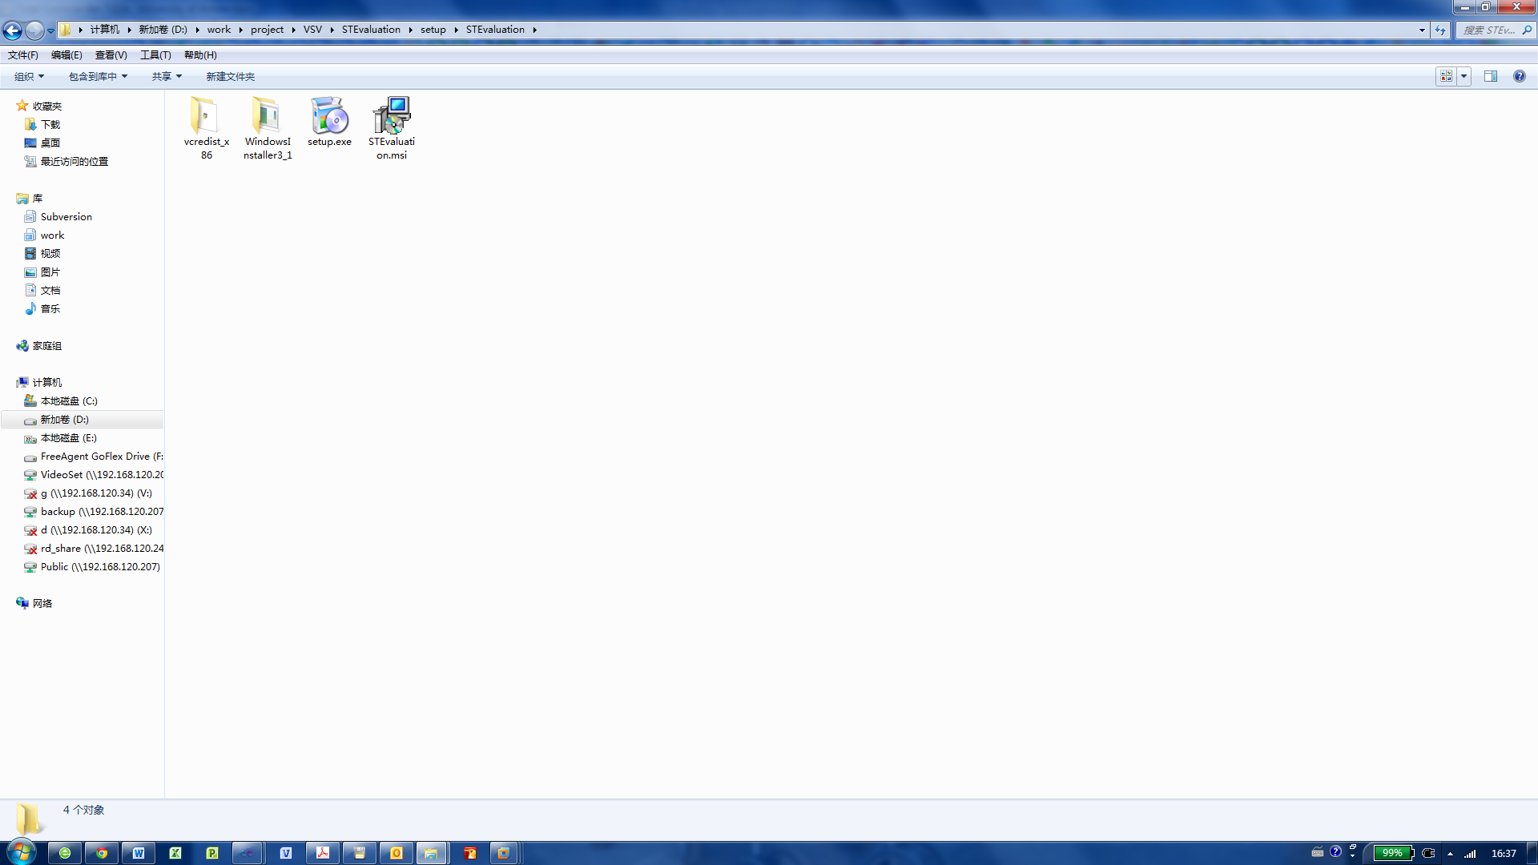

1. **Double click setup.exe to install STEvaluation**

**Installed Directory Structure:**

|  |
| --- |
| STEvaluation:  │ STEvaluation.exe Main program  ├─config Configuration files. Don’t change any files in this directory.  │ └─algocfg  ├─event Events recorder files (*.csv) location. Don’t delete this directory.  └─screenshot Screenshots files location. Don’t delete this directory. |

The installer will check Visual Studio 2010 Redistributable Package. If they haven’t been installed correctly, installation will guide you to install them.

Click **INSTALL** button when you see following dialogs.

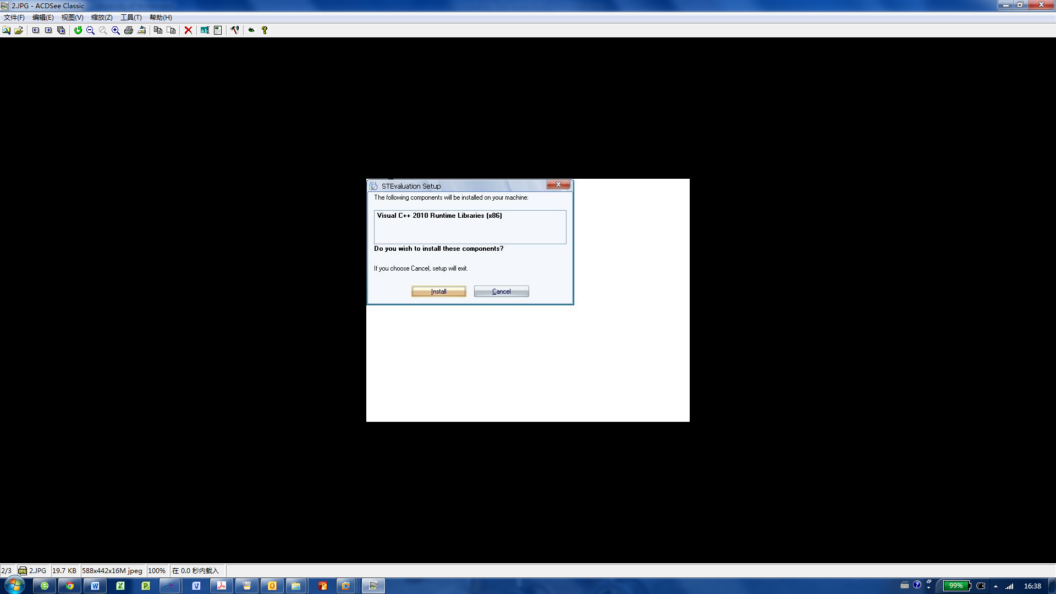

1. **Double click STEvaluation.exe on your desktop to run the ST Evaluation tool.**

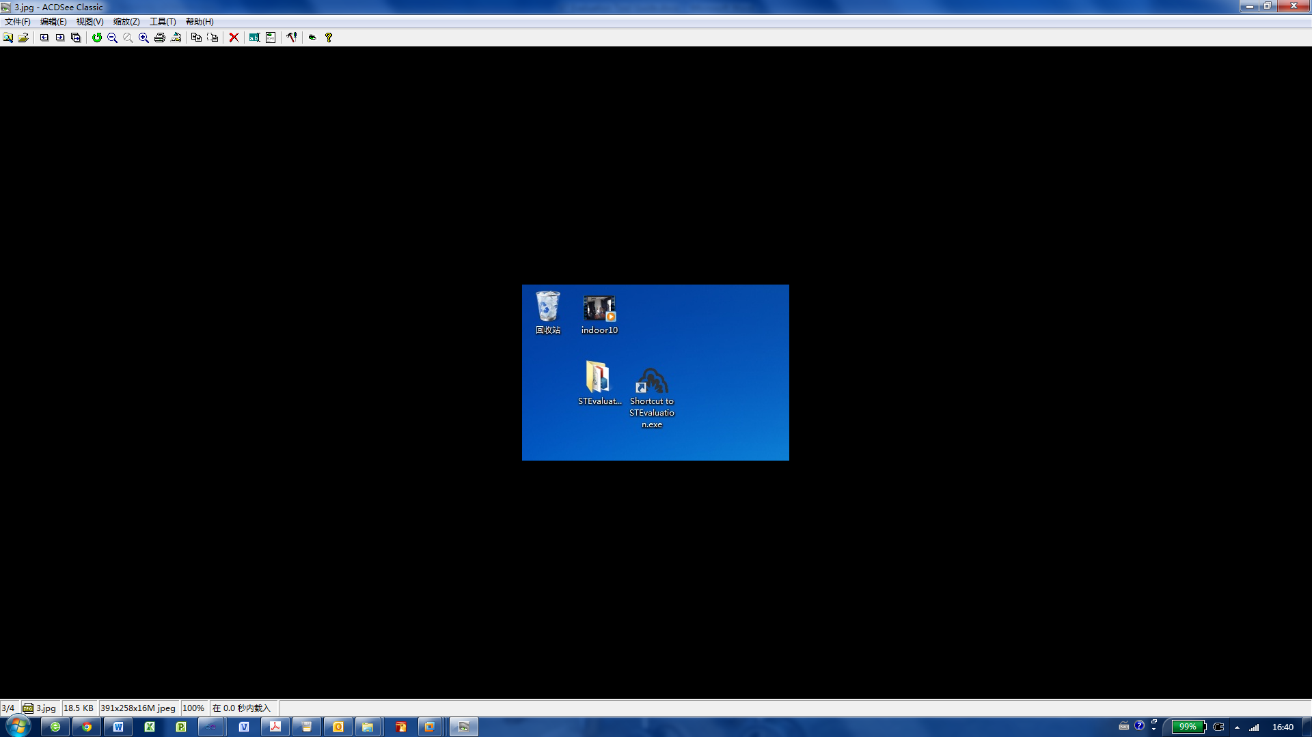

**Login at first**

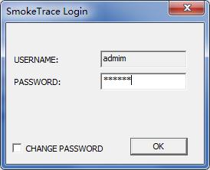 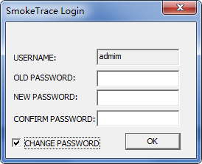

Default password is “123456”.

Check checkbox “Change Password” to change your password.

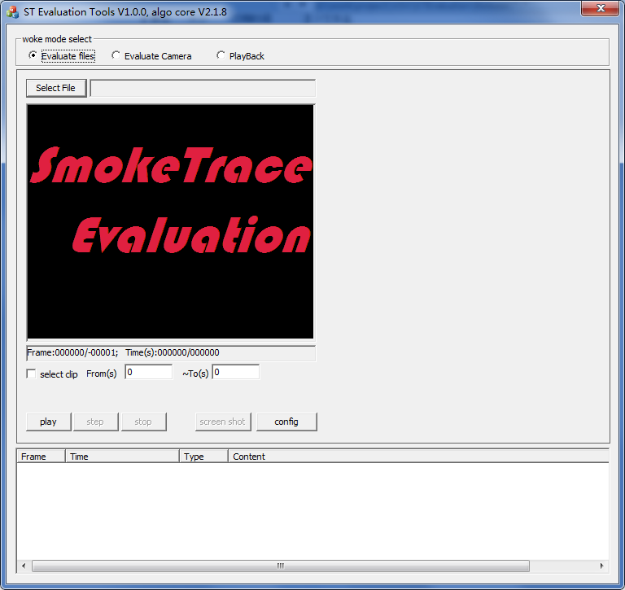

Event List

Work space and control panel

Three woke mode.

# How to start with a file

1: Make sure the target file is a valid video file supported by Windows. It could be opened by Windows Media Player successfully.

ST Evaluation Tool use Window system codec to decode your video files. If you could play video file with Windows Media Player, ask who provide video files to you for help.

2: Select mode of “Evaluate files”

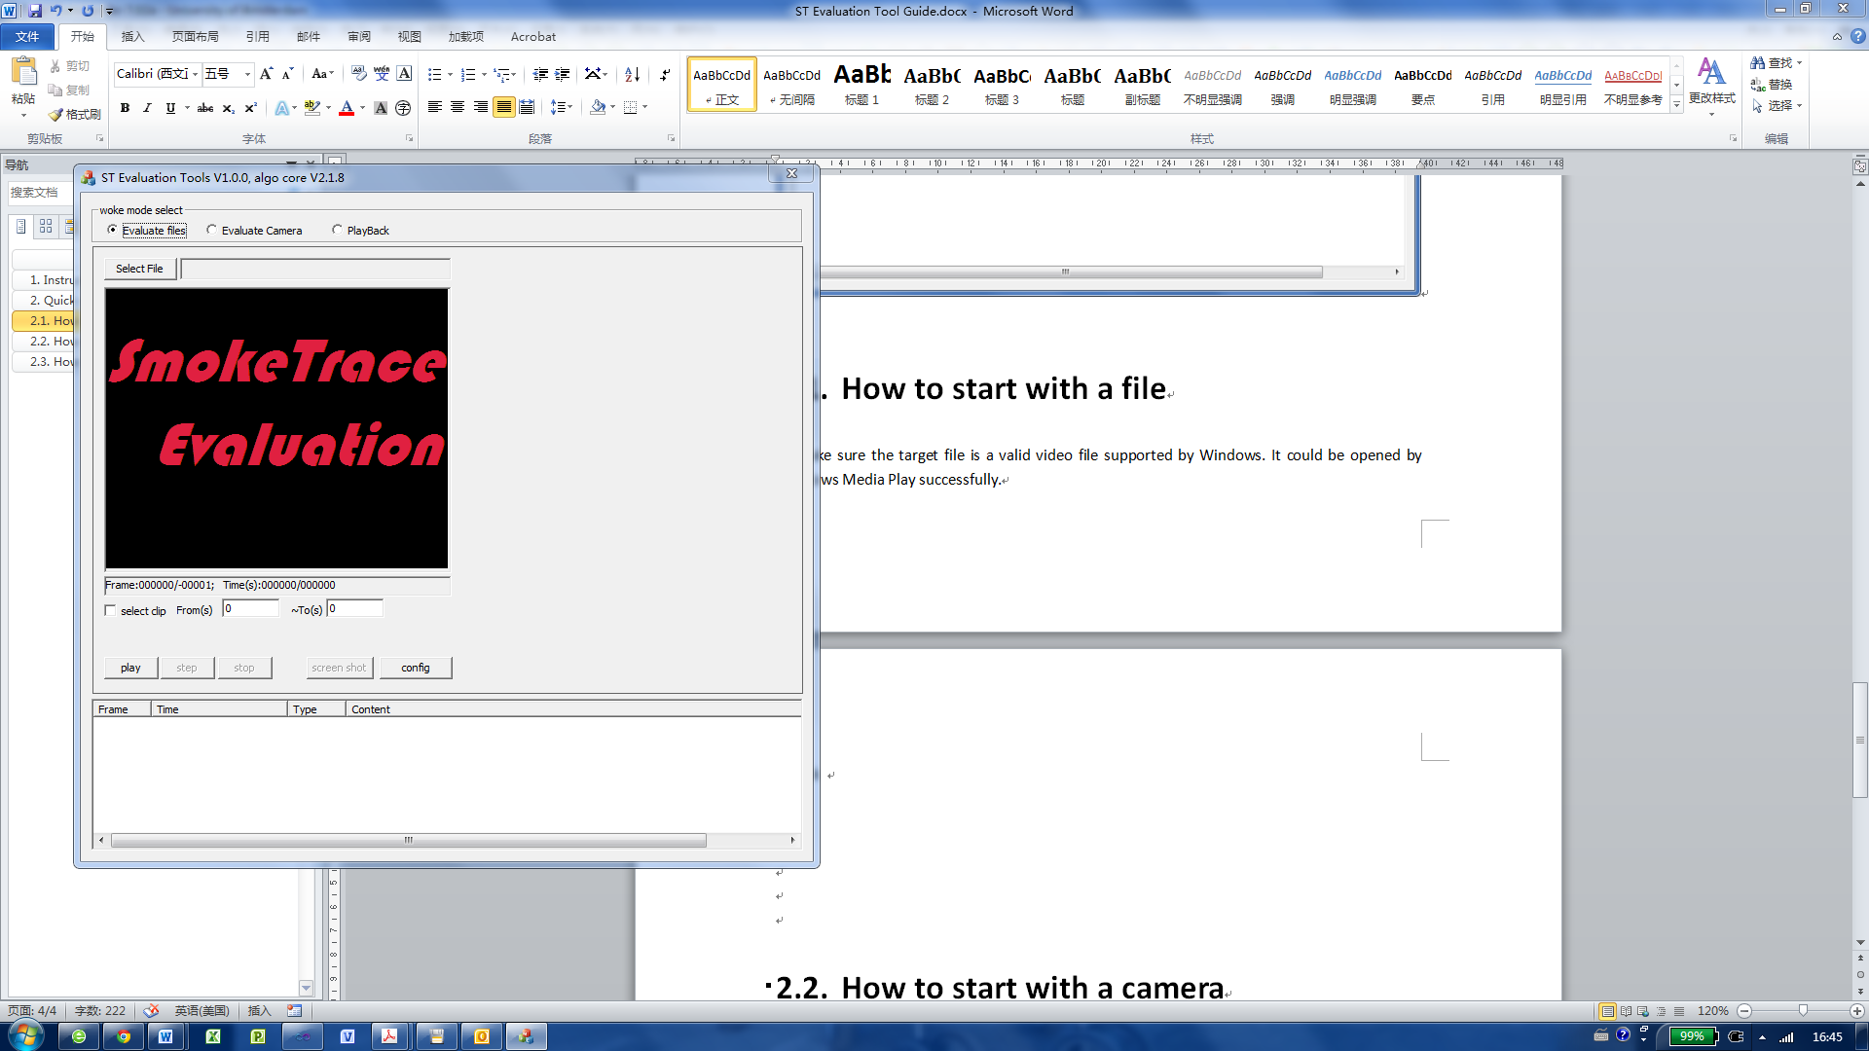

3: Click button “select file” to select a avi file.

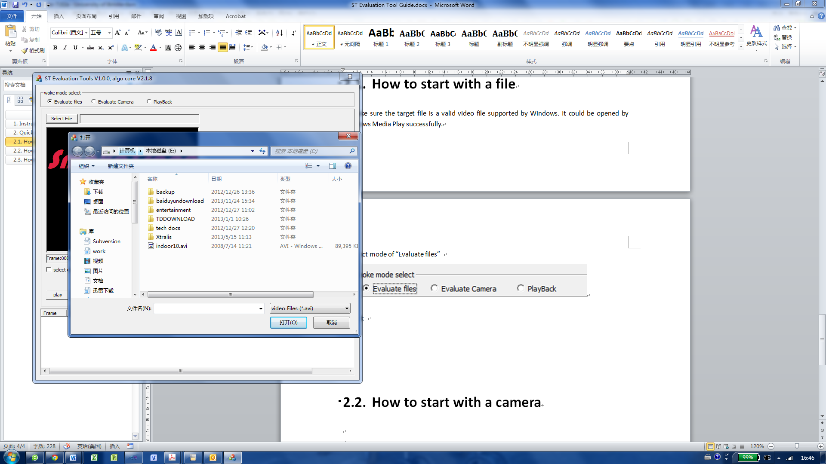

4: Click button “config” to set configuration for SmokeTrace.

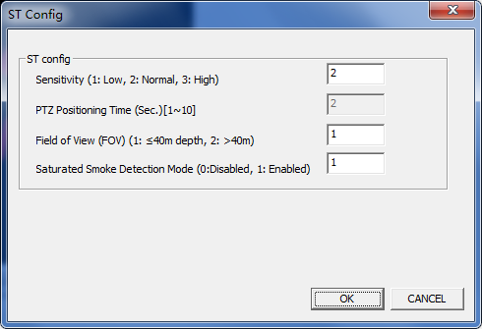

5: Click button “start” to start processing

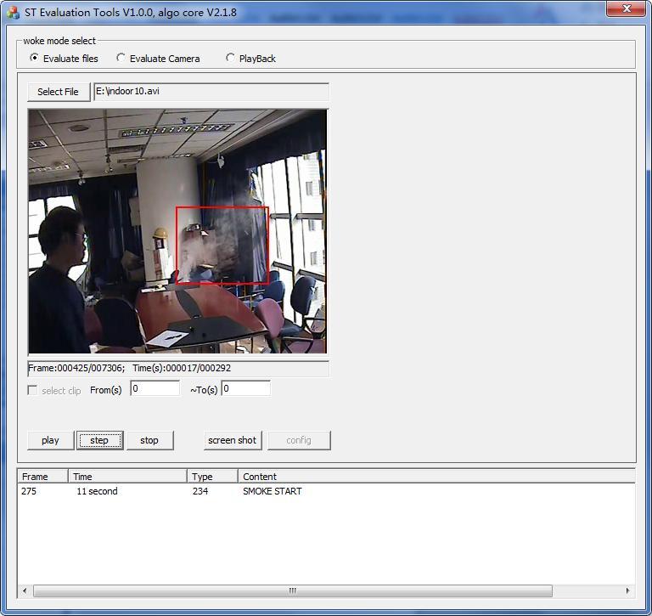

6: During processing, you could click button “step” to pause process to step mode.

Click button “step” again to next frame.

Click button “start” to resume to normal play mode.

Click button “stop” to stop process.

7: When an event occurred, you could see it added in list box. At the same time, the event was recorded in csv file. (The csv file is named the same as input video file, and be saved in same directory)

A targets file name xxxx.dat for playback was saved at the same time.

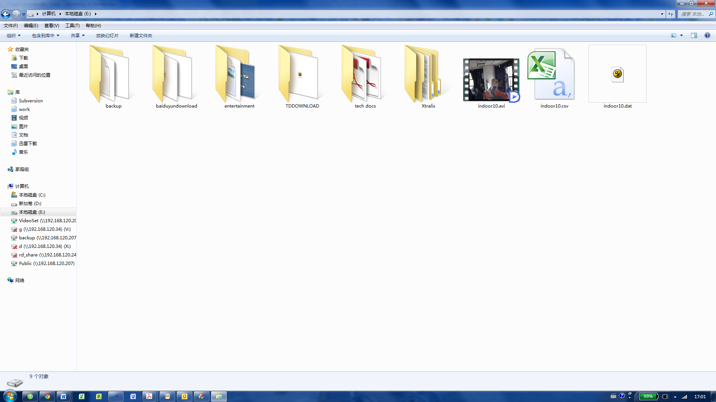

target file

Event file

Input video file

8: Click button “screenshot” to make a screenshot jpg @ resolution 352*288 pixel.

It was saved in directory “./STEvaluation/screenshot”

# How to start with a camera

1. Select mode of “Evaluate files”

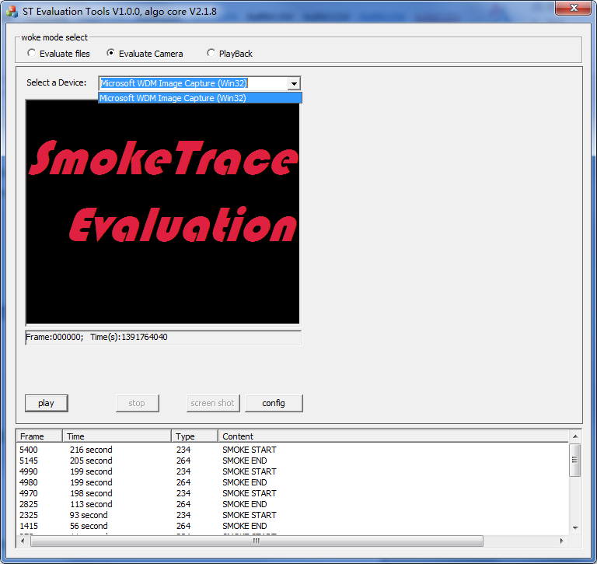

1. If there is a supported device on your computer, you could select it.



1. Select the video capture device and click button “start”.

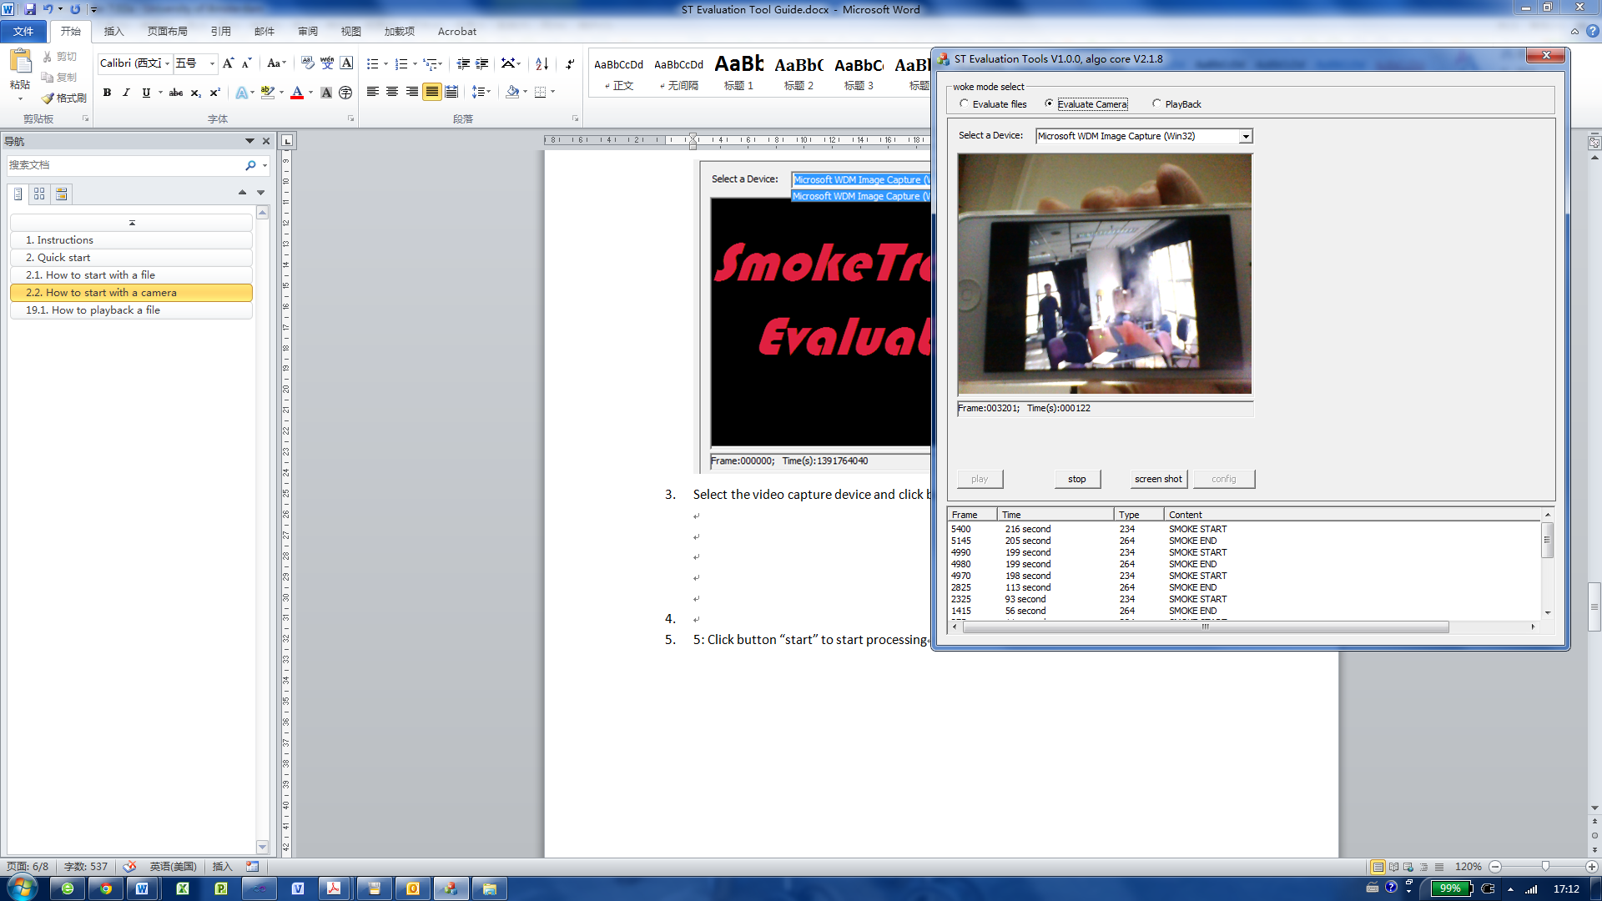

1. When an event occurred, you could see it added in list box. At the same time, the event was recorded in csv file. (The csv file is named by the time , and be saved in directory ”./STEvaluation/event”)

A event will triger a screenshot automatically, it would save 12 pictures with an interval of 12 seconds in “./STEvaluation/screenshot”.

# How to playback a file

After evaluate a xxx.avi file, there should be 3 files in save folder together. (xxx.avi, xxx.dat, xxx.csv). You could replay the avi file with previous results.

1. Select mode of “PlayBack”

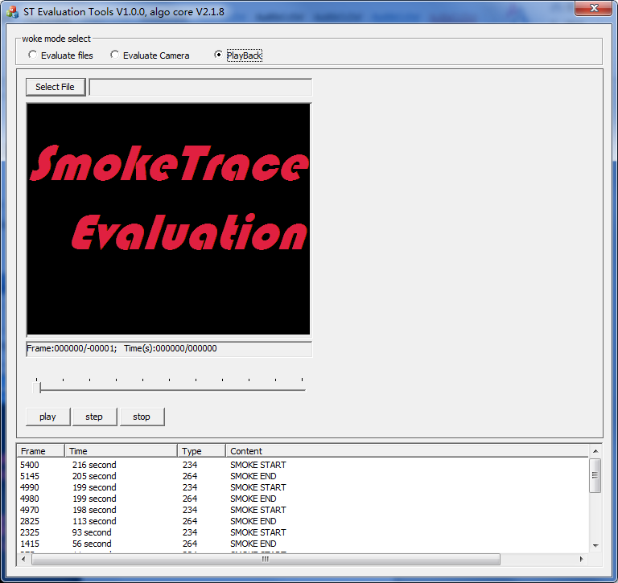

1. Click button “select file” to select a avi file. Make sure that there are xxx.csv and xxx.dat files with it.
2. Click button “start” to start playback.

“Step” mode is valid in playback.

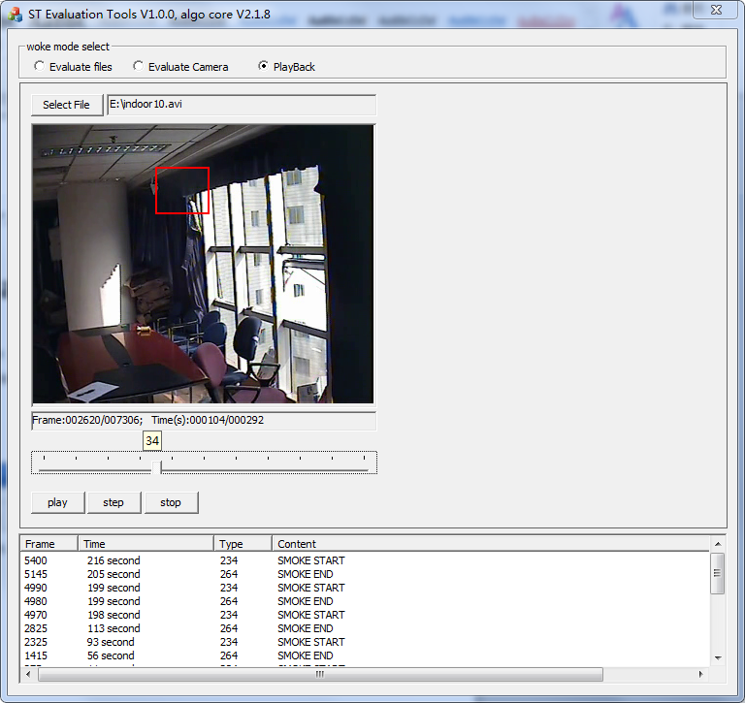

# Format of CSV file

Open file in Microsoft Excel.

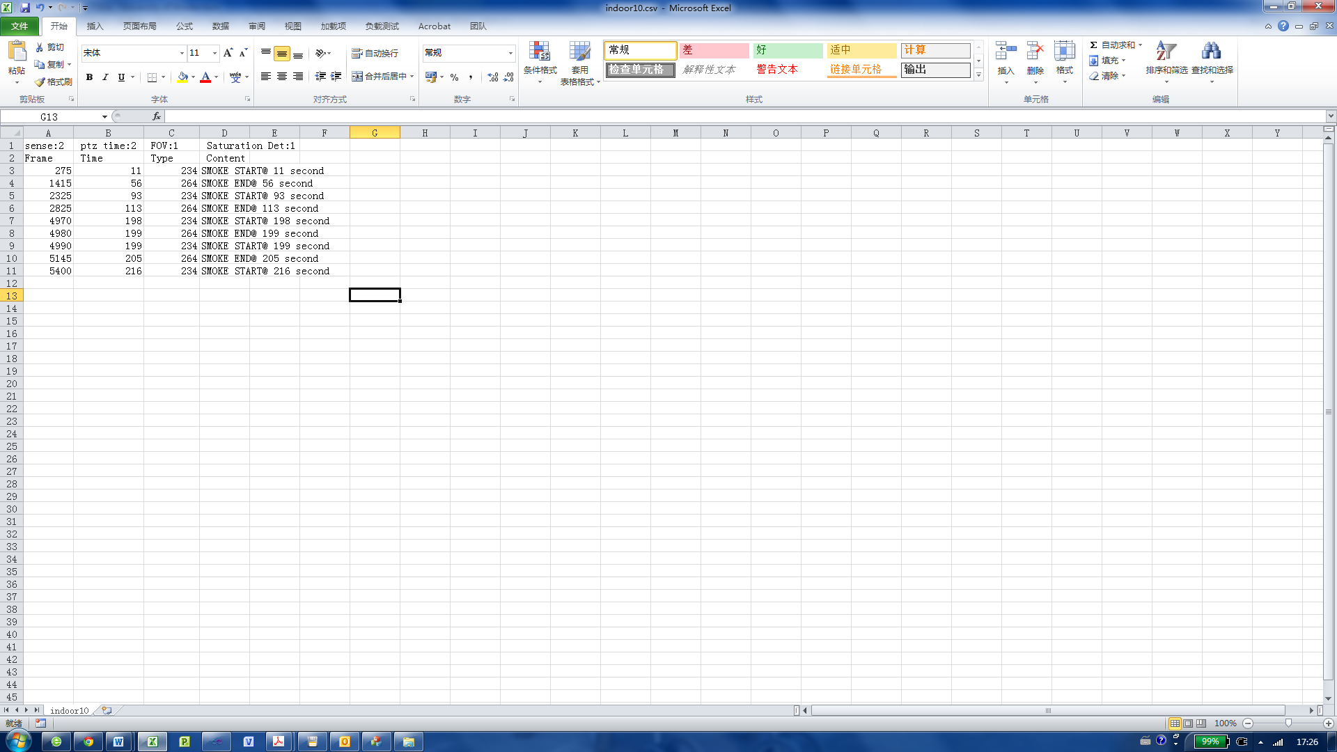

Event description

Time stamp of event

Frame index of event(file mode only)

1 line: configuration used for detection